Profile.me update instructions from v1.2 – v1.3

**Step 1**: Backup ! Backup ! Backup ! you must backup your all files & database before update.

**Step 2**: Download the latest profile.me_1.3 script file and extract it on your pc. Open updates > update_v1.2_v1.3 > you will see **four files** in this folder and you need to upload this files in different folders please follow the below directions carefully.

1. **application.zip** > upload path: Goto your project root folder > application > upload this zip file and extract it.
2. **assets.zip** > upload path: Goto your project root folder > assets > upload this zip file and extract it.
3. **routes.php** > upload path: Goto your project root folder > application > config > upload this file and extract and replace it.
4. **string_helper.php** > upload path: Goto your project root folder > system > helpers > upload this file extract and replace it.

**Step 3**: Upload **“updates”** folder in your project root folder

**Step 4**: Open a browser and write url like this: [www.yourdomain.com/update](http://www.yourdomain.com/update)s/update_v1.2_v1.3 You will see a page like below here enter your item purchase code for update this script.

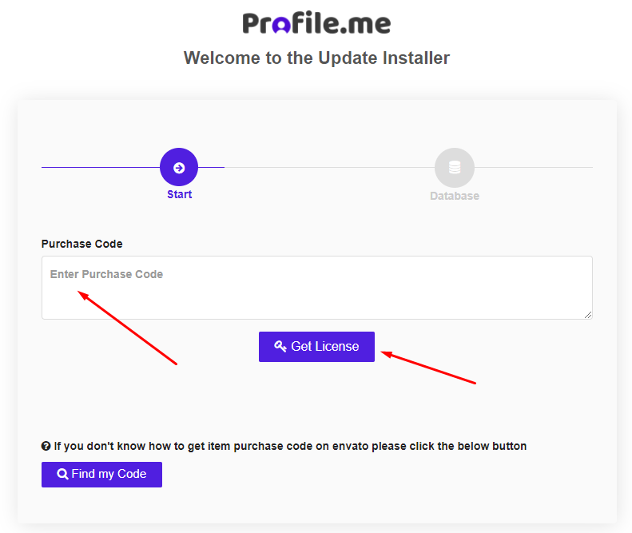

**Step 4**: Here provide your current database credentials and wait few seconds for update your scripts.

